**Creating Web Application in MyeclipseIDE**

* 1. [Create a web project](http://www.javatpoint.com/creating-servlet-in-myeclipse-ide#servletmyeclipse1)
  2. [create a html file](http://www.javatpoint.com/creating-servlet-in-myeclipse-ide#servletmyeclipse2)
  3. [create a servlet](http://www.javatpoint.com/creating-servlet-in-myeclipse-ide#servletmyeclipse3)
  4. [start myeclipse tomcat server and deploy project](http://www.javatpoint.com/creating-servlet-in-myeclipse-ide#servletmyeclipse4)

**1) Create the web project:**

|  |
| --- |
| For creating a web project click on File Menu -> New -> web project -> write your project name e.g. first -> Finish. |

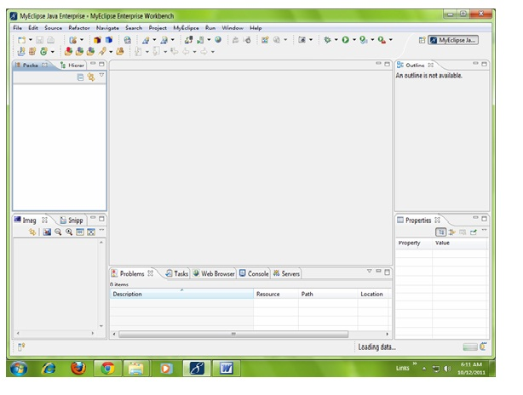

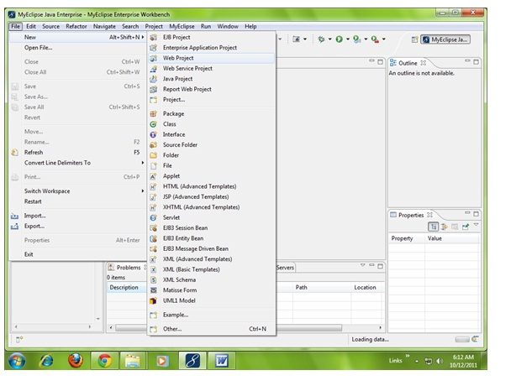

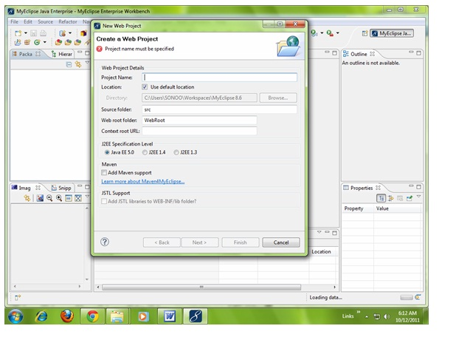

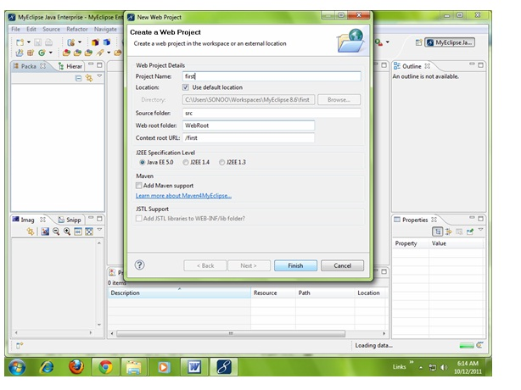

|  |  |
| --- | --- |
| **2) Create the html file:** , right click on WebRoot -> New -> html -> write your html file name e.g. MyHtml.html -> Finish. | |
|  |

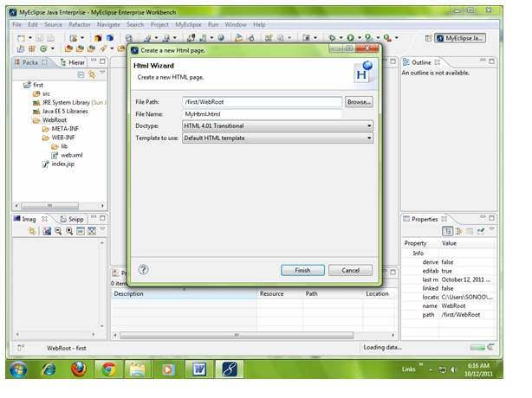

|  |
| --- |
| As you can see that a html file is created named MyHtml.html. Write the html code here. |

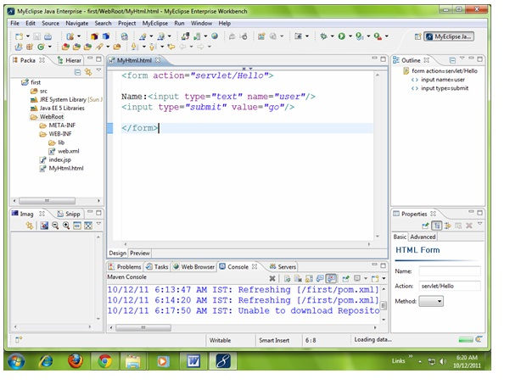

|  |
| --- |
| **3) Create the servlet:** For creating a servlet click on File Menu -> New -> servlet -> write your servlet name e.g. Hello -> uncheck all the checkboxes except doGet() -> next -> Finish. |

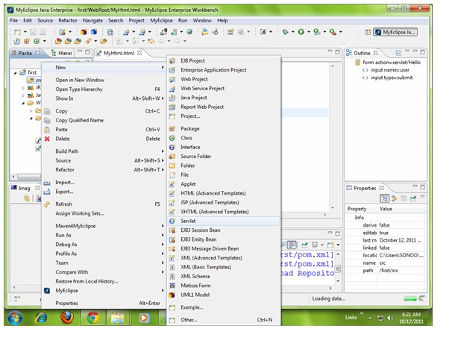

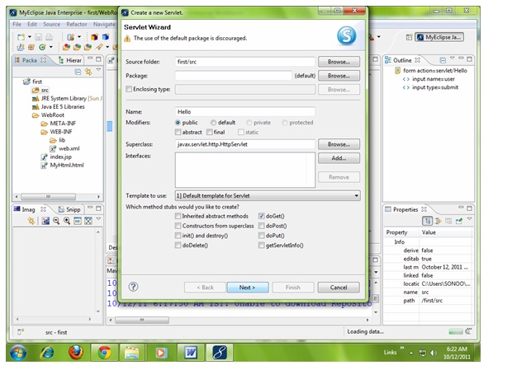

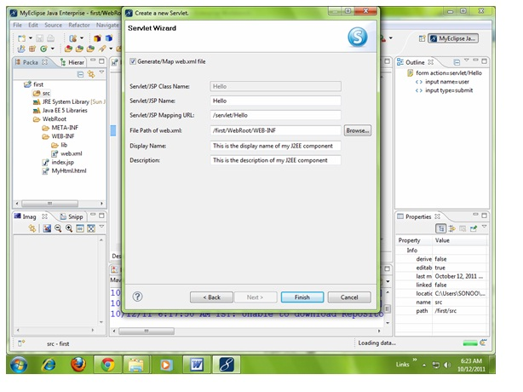

|  |
| --- |
| As you can see that a servlet file is created named Hello.java. Now let's write the servlet code here. |

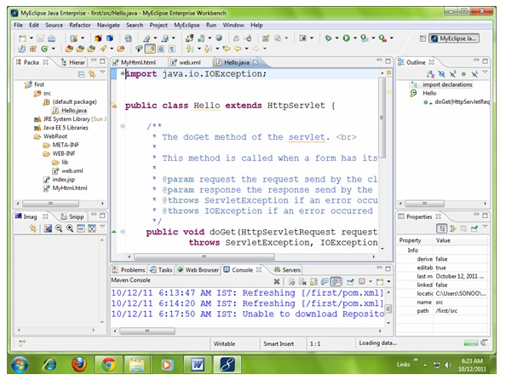

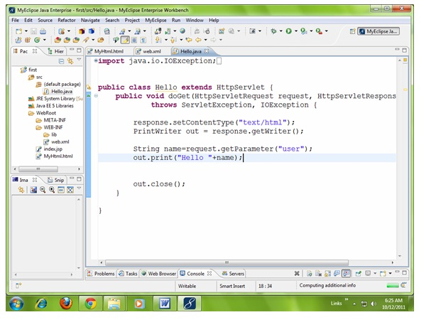

|  |
| --- |
| Now let's make the MyHtml.html file as the default page of our project. For this, open web.xml file and change the welcome file name as MyHtml.html |

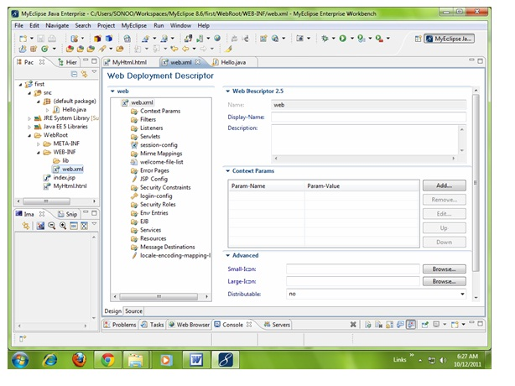

|  |
| --- |
| Now change the welcome file as MyHtml.html. |

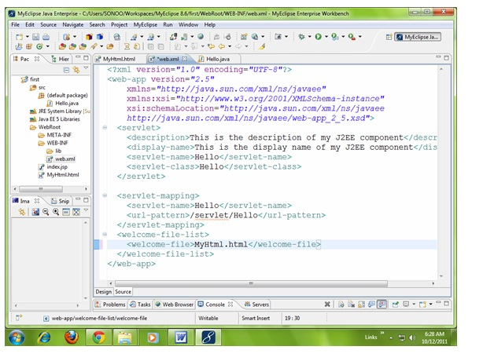

**4) Start the server and deploy the project:**

|  |
| --- |
| For starting the server and deploying the project in one step Right click on your project -> Run As -> MyEclipse server application. |
| **Note:** For changing the port number click on the start server icon at the left hand side of browser icon -> myeclipse tomcat -> Configure server connector -> change the port number as xxxx in place of old portno -> apply -> ok. |

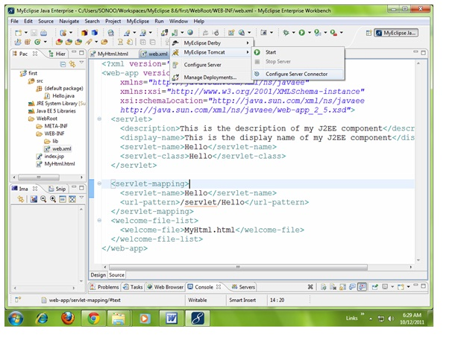

|  |
| --- |
| Set the portno based on requirement -> apply -> ok. |

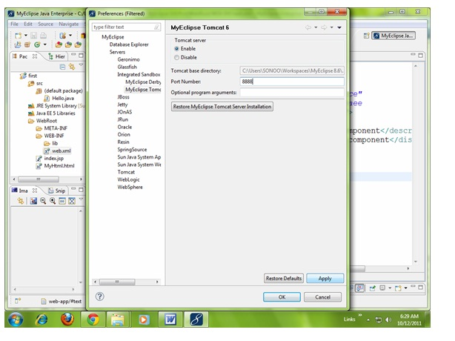

|  |
| --- |
| Now port number have been changed. For starting the server Right click on your project -> Run As -> MyEclipse server application. |

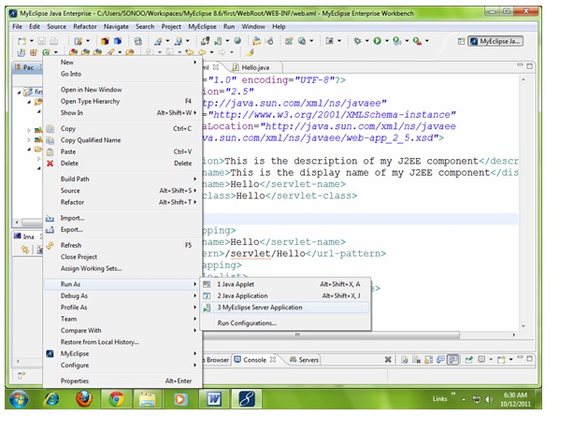

|  |
| --- |
| As you can see that default page of your project is open, write your name -> go. |

